Day 52 – Universal Gates Using DEMUX

Introduction:Universal gates are logic gates that can be used to implement any Boolean function. NAND and NOR are called universal gates because all basic logic gates can be constructed using either NAND gates or NOR gates.

1. NAND Gate Using DEMUX

Design:The NAND gate is implemented using a DEMUX by obtaining the AND function and complementing its output.
Boolean Expression: Y = (A · B)'
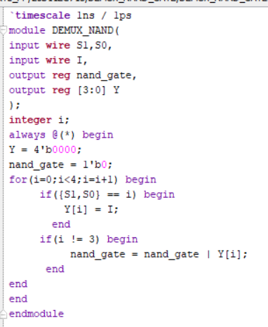
Testbench:The testbench applies all possible combinations of inputs A and B to verify the NAND gate operation.

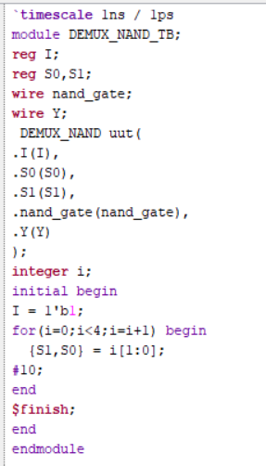

Waveform:The waveform verifies that the output is LOW only when both inputs are HIGH.

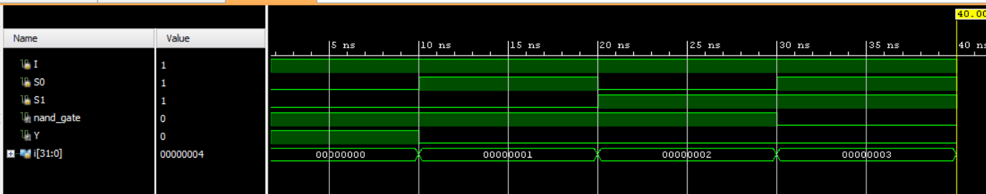

Schematic:The RTL schematic of the NAND gate implemented using DEMUX is generated and analyzed using Xilinx Vivado.

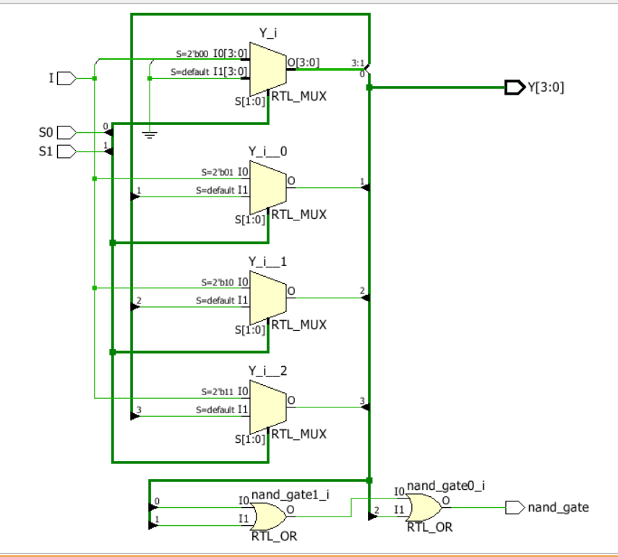

2. NOR Gate Using DEMUX

Design: The NOR gate is implemented using a DEMUX by obtaining the OR function and complementing its output.
Boolean Expression:
Y = (A + B)'
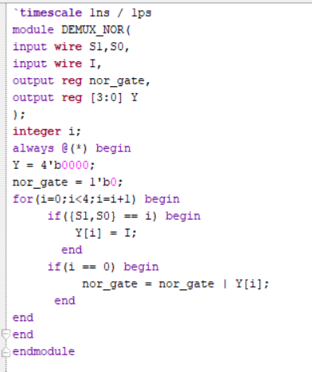

Testbench:The testbench applies all possible combinations of inputs A and B to verify the NOR gate operation.
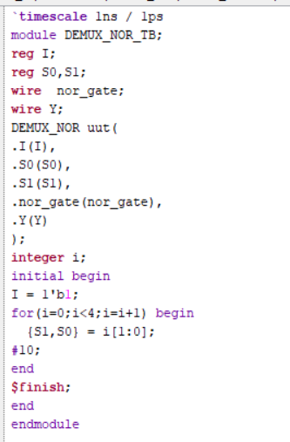

Waveform:The waveform verifies that the output is HIGH only when both inputs are LOW.

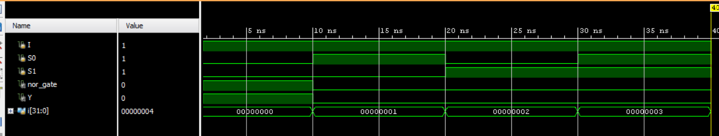

Schematic
The RTL schematic of the NOR gate implemented using DEMUX is generated and analyzed using Xilinx Vivado.
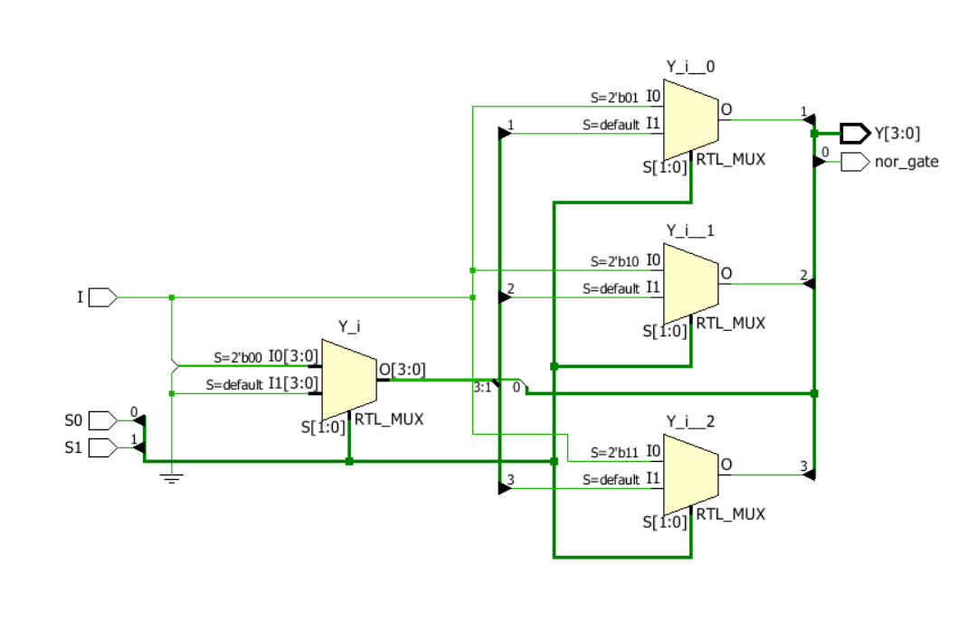

Observation
The NAND and NOR gates were implemented using DEMUX-based logic and verified through simulation. This experiment helped me understand universal gates, Boolean function implementation, and DEMUX applications in combinational logic design.

#PHANEENDRA.SINGUDASU

